**Name: Emir Yiğit Akpınar Student ID: 28139**

**ChatGPT Chat Link: https://chat.openai.com/share/bbc35153-08df-43f7-ae22-ea5736bb330a**

**CS 405 Project 1 Report**

This project aims to generate a 3D object and animate it in 3D space with using WebGL. The project involves 3 main tasks. The project suggest to use the OpenAI’s text base artificial intelligence language model ChatGPT 3.5 in each task.

The first task involves that creating a transformation matrix with using ChatGPT 3.5. When we enter the given prompt text file called “transformation-prompt.txt” into ChatGPT the instructions were given correctly by the ChatGPT. However, the transformation matrix was not created. Another prompt “Please calculate this matrix by yourself” was given to the ChatGPT. Then a transformation matrix with 4x4 sizes was created by ChatGPT. However, this matrix similar yet a little bit different than the project’s PDF file. The reason behind that could stem from the matrix multiplication order difference which is the error made by ChatGPT or could stem from the trigonometric function error (also chatGPT gives the angles in degree form not radians). The transformation matrix was pasted into utils.js file. In Figure 1 the shape which is created by this transformation matrix for task 1 can be seen. Also at the top of the document the ChatGPT chat link can be accessed.



**Figure 1**

The model view matrix should be calculated by the functions which is avaliable in the utils.js file to accomplish task 2. According to lectures and ChatGPT the transformation matrix multiplication order should be in T * S * Rx * Ry * Rz order where T is translation, S is scaling, Rx is rotation in X cordinates , Ry is rotation in Y cordinates, Rz is rotation in Z cordinates. The matrix multiplication has performed right side to left side i.e. the leftside operand is the second parameter of the multiplyMatrices function and the first parameter of the function is the right hand side operand. The given values in the “transformation-prompt.txt” file have been set as parameters into given functions such as createTranslationMatrix(0.3, -0.25, 0), createScaleMatrix (0.5, 0.5, 1), createRotationMatrix_X(Math.PI/6) etc. The given degree values have been converted into radians values with math.pi function to properly use the given functions in utils.js. The shape created by getModelViewMatrix can be seen in **Figure 2.**

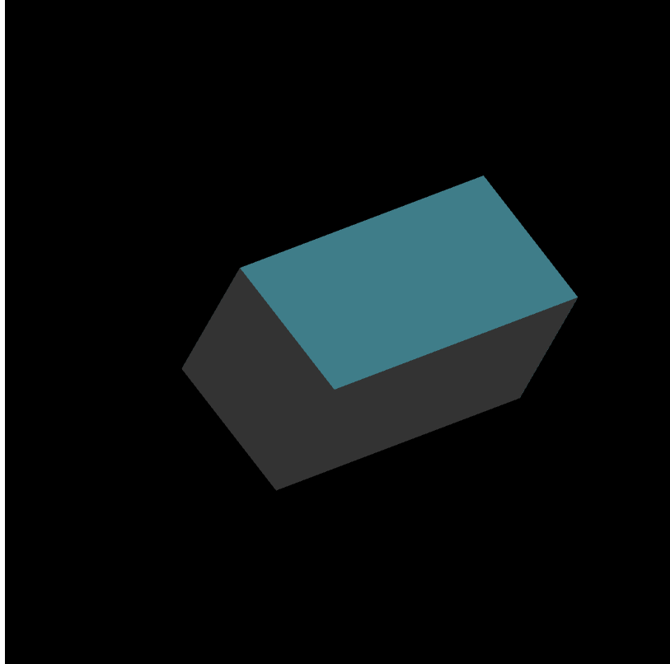

**Figure 2**

At the third and the final task of the project. The cube should be animated by using chatGPT. In the first 5 seconds of the animation the first phase has happened. In that phase the 3D object starts to transform to transformation matrix which has been calculated in task 2. At the second phase the object will return its initial state. For that a simple if else statement is used. A cycle variable is defined as 10 to represent 10 seconds. The phase variable depends on the cycle variable and the transportation matrix changes accordingly. Interpolation matrix is iterating 16 times for each phase. Therefore the 3D object is animated as 10 second periods. The chatGPT link can be found on the top of the document.